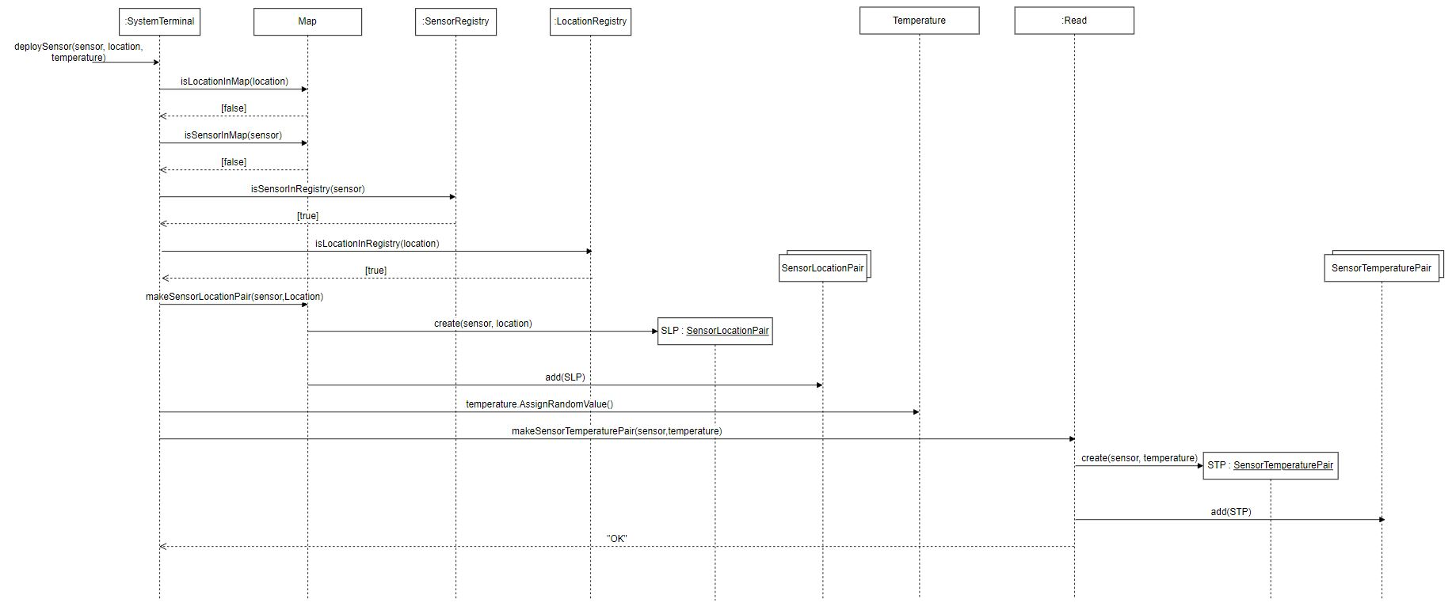**UML Sequence Diagram for DeploySensor (updated for Phase 2)**

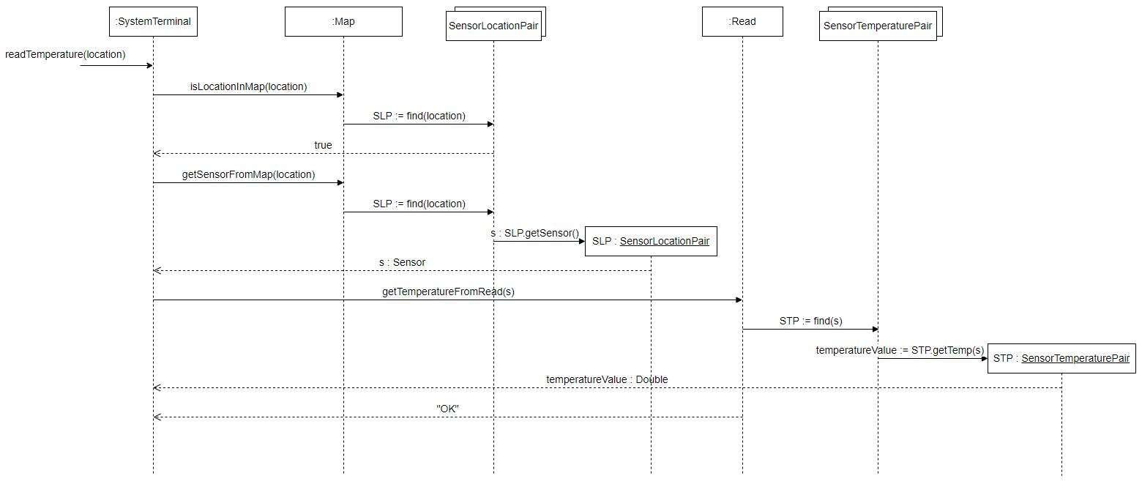 **UML Sequence Diagram for ReadTemperature (updated for Phase 2)**

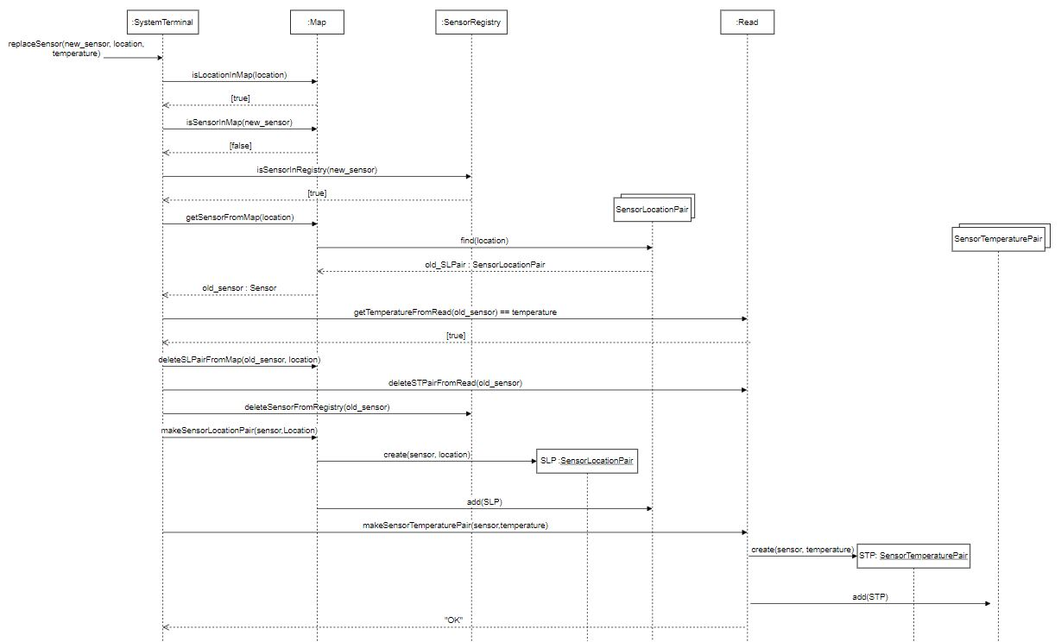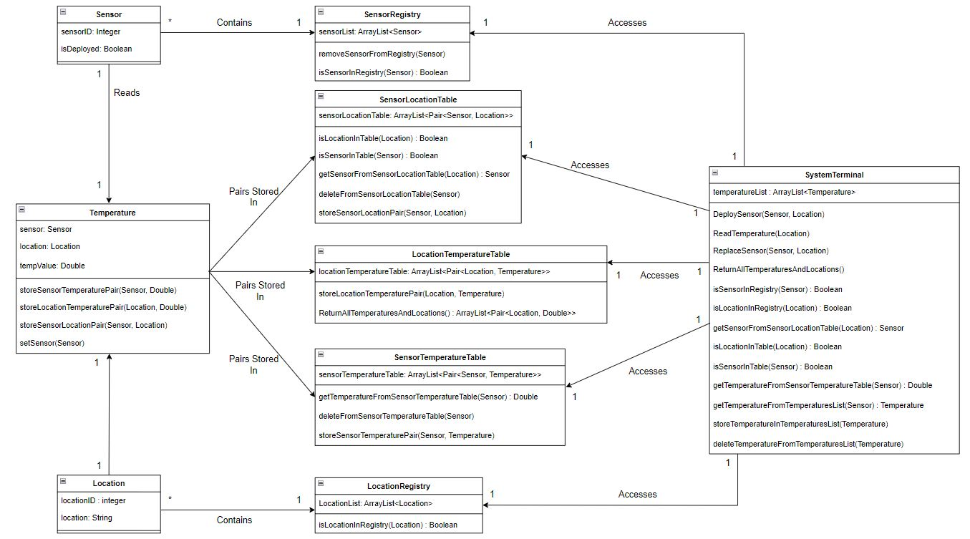 **UML Sequence Diagram for ReplaceSensor (new functionality in Phase 2)**

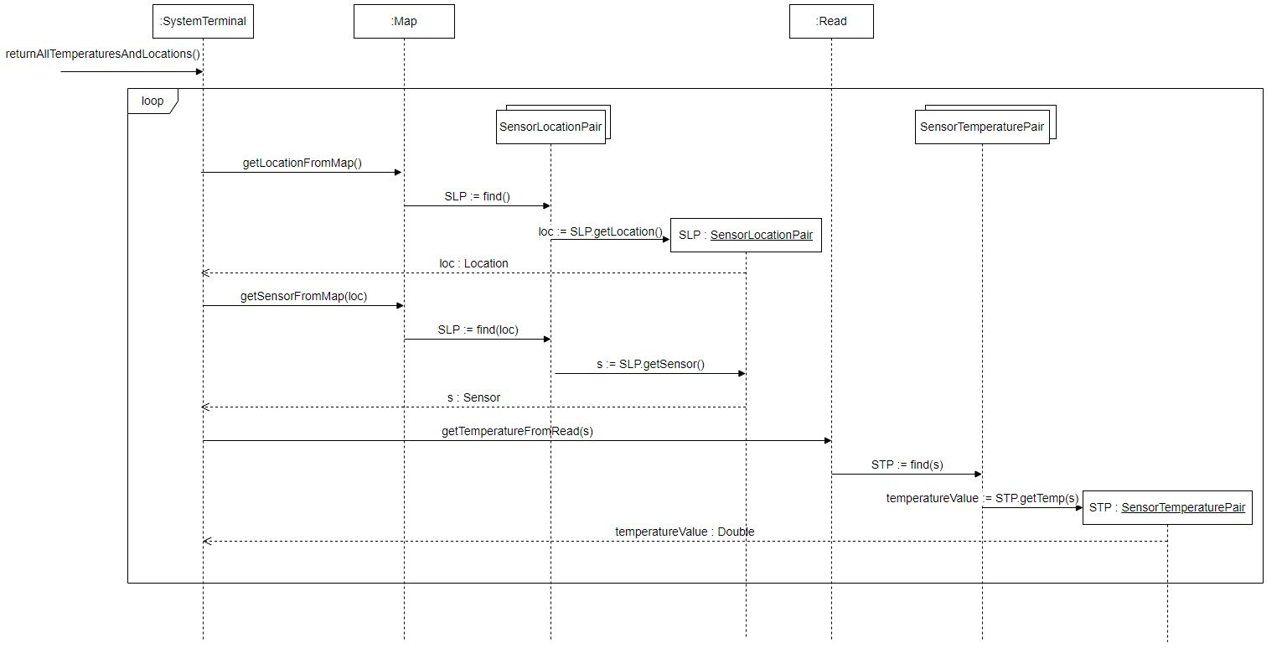**UML Sequence Diagram for ReturnAllTemperaturesAndLocations (new functionality in Phase 2)**

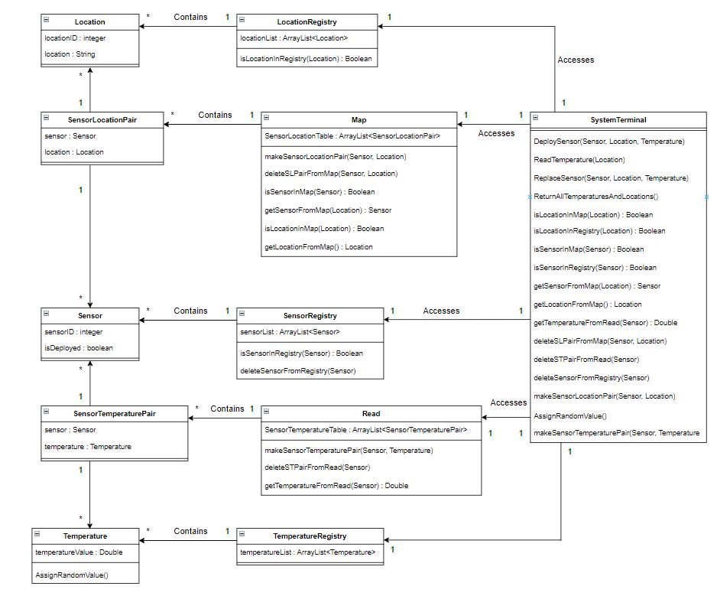**UML Class Diagram (updated for Phase 2)**